

Assessment - 1

TITLE
Diabetes Detection Using Machine Learning
Submitted by
Class and Section: ISE-A

Team Lead: Aishwarya MN– R23EQ051
Keerthana S– R23EQ051
Keerthana NP– R23EQ049

Under the Guidance of: Ms. Bhavana

Date: 02 December 2024

DIABETES DETECTION USING ML

Abstract
Diabetes is one of the most common chronic diseases worldwide, and early detection plays a crucial role in preventing complications. Traditional diagnosis relies on medical tests and manual evaluation, which may be time consuming and sometimes inaccurate due to human error. Machine Learning (ML) models provide a more efficient and reliable method to assist in diagnosing diabetes.This project develops a supervised machine learning model, specifically a Random Forest , trained on the PIMA Diabetes Dataset, to predict whether a person has diabetes based on medical features such as glucose level, BMI, age, etc.
The study includes data preprocessing, model training, evaluation using accuracy, precision, recall, and confusion matrix, and a comparison of performance between ML algorithms.

1. Introduction

1.1 Background
Diabetes is a metabolic disorder characterized by high blood sugar levels. Early diagnosis helps prevent severe health issues. With the rise of ML, computer-based prediction systems have shown promising results in medical diagnosis.
Machine Learning models can analyze patterns hidden in medical datasets that may not be easily visible to humans, leading to faster and more accurate predictions.
In this project, we build and evaluate ML models on the PIMA Diabetes Dataset, a widely used medical dataset for classification tasks.

1.2 Problem Statement
To design and implement a machine learning model that predicts whether an individual is diabetic based on medical parameters. This includes data cleaning, preprocessing, feature scaling, model building, and performance evaluation.

1.3 Objectives

  - To analyze and preprocess the PIMA Diabetes dataset.
  - To build ML models such as Logistic Regression, SVM, KNN, and Random Forest.
  - To evaluate models using accuracy, confusion matrix, precision, recall, and F1-score.
  - To determine the best-performing ML algorithm for diabetes prediction.

2. Literature Review
2.1 Diabetes Prediction Using Machine Learning
ML has been widely used in medical diagnosis. Popular algorithms include:
- Logistic Regression → Good baseline for medical classification.
- K-Nearest Neighbors (KNN) → Simple and effective for small datasets.
- Support Vector Machine (SVM) → Performs well with high-dimensional data.
- Random Forest → Handles missing values and gives high accuracy.

2.2 PIMA Diabetes Dataset
This dataset contains 768 patient records with 8 features:
- Pregnancies
- Glucose
- Blood Pressure
- Skin Thickness
- Insulin
- BMI
- Diabetes Pedigree Function
- Age
- Outcome (0 = No diabetes, 1 = Diabetes)

2.3 Importance of ML in Healthcare
ML models help in:
- Reducing costs
- Early diagnosis
- Predictive medical assistance
- Supporting doctors with automated decision systems

3. Methodology

3.1 Data Collection and Preprocessing

For this project, we used the PIMA Diabetes Dataset, which is one of the most widely used datasets for diabetes prediction research. It is publicly available on platforms like Kaggle and the UCI Machine Learning Repository.
The dataset contains 768 patient records collected from women of Pima Indian heritage, aged 21 years and above. Each record includes 8 medical features that are clinically relevant for predicting diabetes:
- Pregnancies – Number of times the patient has been pregnant
- Glucose – Plasma glucose concentration after a 2-hour oral glucose tolerance test
- Blood Pressure – Diastolic blood pressure (mm Hg)
- Skin Thickness – Triceps skin fold thickness (mm)
- Insulin – 2-hour serum insulin (mu U/ml)
- BMI – Body Mass Index
- Diabetes Pedigree Function – Likelihood of diabetes based on family history
- Age – Age of the patient
- Outcome – Target variable (0 = No Diabetes, 1 = Diabetes)
The dataset is selected because:
- It’s clean and widely studied
- It contains real medical attributes
- It is ideal for binary classification (diabetic vs non-diabetic)
This makes it suitable for testing various machine learning algorithms.

3.2 Model Architecture
In this project, we experimented with multiple Machine Learning classification algorithms to identify which model performs best for predicting diabetes. Each algorithm learns patterns from the medical features in the dataset and attempts to classify a patient as diabetic (1) or non-diabetic (0).
The overall model architecture follows these main steps:

1. Input Layer (Features)
The model receives 8 medical input features, such as Glucose, BMI, Age, Blood Pressure.
These features are scaled and fed into different ML algorithms for training.

2. Machine Learning Algorithms Used
To determine the best-performing classifier, we used four different models, each with its unique architecture and working principle:

a) Logistic Regression
- A statistical method used for binary classification (0 or 1).
- Uses a sigmoid activation function to convert input features into a probability between 0 and 1.
- The model tries to find a linear decision boundary separating diabetic and non-diabetic patients.
- It is simple, efficient, and serves as an excellent baseline classifier.

b) Support Vector Machine (SVM)
- SVM finds the best separating hyperplane that divides the classes with maximum margin.
- Uses kernels (linear, RBF) to capture non-linear patterns in data.
- Works very well when features are scaled.
- Effective in high-dimensional spaces and performs consistently for medical classification problems.

c) K-Nearest Neighbors (KNN)
- A distance-based classifier.
- No training happens like traditional models — instead, it stores all data points.
- For a new patient, it looks at the ‘k’ closest data points and predicts the majority class.
- Works best with scaled data and when k is chosen appropriately.

d) Random Forest Classifier
- A powerful ensemble model made of many decision trees.
- Each tree makes a prediction and the final output is chosen by majority voting.
- Handles both linear and non-linear patterns well.
- Reduces overfitting and usually gives the highest accuracy for this dataset.
- Good for feature importance analysis.

3.3 Model Training and Evaluation
Model training involves teaching the machine learning algorithms to understand patterns in the dataset and correctly classify whether a patient is diabetic or not. The dataset is first divided into 80% training data and 20% testing data to ensure that the model is evaluated on unseen records. Feature scaling is applied using StandardScaler so that all input features are on a similar range, which improves performance for algorithms like SVM, Logistic Regression, and KNN.
Each model—Logistic Regression, SVM, KNN, and Random Forest—is trained on the training data by learning relationships between the input medical features and the output class. After training, the models are tested using the test dataset to check how well they generalize. Evaluation metrics such as accuracy, confusion matrix, precision, recall, and F1-score are used to measure performance. These metrics help identify how many diabetic patients were correctly detected and how many were misclassified. Based on the evaluation results, the Random Forest Classifier typically performs best due to its ability to handle non-linear patterns and reduce overfitting.

4. Results and Discussion
After training all four machine learning models, their performance was evaluated using accuracy, confusion matrix, precision, recall, and F1-score. Among the algorithms tested, Random Forest Classifier achieved the highest accuracy, followed by SVM and Logistic Regression, while KNN showed comparatively lower performance. The Random Forest model was able to correctly identify most diabetic cases due to its ability to handle non-linear relationships and variations in the dataset.
Model | Accuracy | Remarks
Logistic Regression | ~77% | Good baseline
SVM | ~78–80% | Performs better after scaling
KNN | ~72–74% | Depends on distance metric
Random Forest | 80–85% | Best performance

4.2 Future Work
This project can be extended by using larger and more diverse medical datasets to improve prediction accuracy. Advanced algorithms such as Gradient Boosting, XGBoost, or deep learning models can also be explored. Including additional medical parameters like HbA1c levels or lifestyle information may lead to more precise results.
- Collect a larger and more diverse dataset to improve generalization.
- Explore advanced models like XGBoost, CatBoost, or Neural Networks.
- Include additional features such as diet, physical activity, and medical history.
- Develop a mobile or web-based interface for real-time diabetes prediction.
- Integrate the model with hospital databases or IoT health monitoring devices.

Code:
import os
import pandas as pd
import numpy as np
import matplotlib.pyplot as plt
import joblib
import warnings
warnings.filterwarnings('ignore')
from sklearn.model_selection import train_test_split, GridSearchCV
from sklearn.preprocessing import StandardScaler
from sklearn.linear_model import LogisticRegression
from sklearn.ensemble import RandomForestClassifier
from sklearn.metrics import accuracy_score, confusion_matrix, classification_report, roc_curve, auc
DATA_PATH = '/content/diabetes.csv'
if not os.path.exists(DATA_PATH):
raise FileNotFoundError(f"Dataset not found at {DATA_PATH}. Please upload or check path.")
df = pd.read_csv(DATA_PATH)
print("Dataset loaded. Shape:", df.shape)
display(df.head(10))
print("\nColumns:", list(df.columns))

print("Libraries loaded.")
print("=== INFO ===")
print(df.info())
print("\n=== Missing values per column ===")
print(df.isnull().sum())
print("\n=== Basic statistics ===")
display(df.describe())
candidate_cols = ['Glucose','BloodPressure','SkinThickness','Insulin','BMI']
cols_present = [c for c in candidate_cols if c in df.columns]
print("Columns to treat 0->NaN if present:", cols_present)
for c in cols_present:
df[c] = df[c].replace(0, np.nan)
print("\nMissing values after 0->NaN conversion:")
print(df.isnull().sum())
num_cols = df.select_dtypes(include=[np.number]).columns.tolist()
for c in num_cols:
if df[c].isnull().sum() > 0:
med = df[c].median()
df[c] = df[c].fillna(med)
print(f"Filled NaNs in {c} with median = {med}")
possible_targets = ["Outcome","outcome","target","label","Result","result"]
target_col = None
for t in possible_targets:
if t in df.columns:
target_col = t
break
if target_col is None:
target_col = df.columns[-1]
print("Using target column:", target_col)
X = df.drop(columns=[target_col])
y = df[target_col]
print("Features shape:", X.shape, "Target shape:", y.shape)
display(X.head())
X_train, X_test, y_train, y_test = train_test_split(
X, y, test_size=0.20, random_state=42, stratify=y)
print("Train shape:", X_train.shape, "Test shape:", X_test.shape)
scaler = StandardScaler()
X_train_scaled = scaler.fit_transform(X_train)
X_test_scaled = scaler.transform(X_test)
print("Feature scaling completed.")
lr = LogisticRegression(max_iter=1000, solver='liblinear')
lr_params = {'C':[0.01, 0.1, 1, 10]}
lr_cv = GridSearchCV(lr, lr_params, cv=5, scoring='accuracy', n_jobs=-1)
lr_cv.fit(X_train_scaled, y_train)
best_lr = lr_cv.best_estimator_
print("LogisticRegression best params:", lr_cv.best_params_)
rf = RandomForestClassifier(random_state=42)
rf_params = {'n_estimators': [50, 100], 'max_depth': [None, 5, 10]}
rf_cv = GridSearchCV(rf, rf_params, cv=5, scoring='accuracy', n_jobs=-1)
rf_cv.fit(X_train, y_train)
best_rf = rf_cv.best_estimator_
print("RandomForest best params:", rf_cv.best_params_)
models = {'LogisticRegression': best_lr, 'RandomForest': best_rf}
results = {}
for name, model in models.items():
X_eval = X_test_scaled if name == 'LogisticRegression' else X_test
y_pred = model.predict(X_eval)
acc = accuracy_score(y_test, y_pred)
cm = confusion_matrix(y_test, y_pred)
cr = classification_report(y_test, y_pred, digits=4)
roc_auc = None
if hasattr(model, "predict_proba"):
probs = model.predict_proba(X_eval)[:,1]
fpr, tpr, _ = roc_curve(y_test, probs)
roc_auc = auc(fpr, tpr)
results[name] = {'accuracy': acc, 'confusion_matrix': cm, 'report': cr, 'roc_auc': roc_auc}
print(f"\n=== {name} ===")
print("Accuracy:", acc)
print("Confusion Matrix:\n", cm)
print("Classification Report:\n", cr)
print("ROC AUC:", roc_auc)
best_model_name = max(results.keys(), key=lambda k: results[k]['accuracy'])
best_model = models[best_model_name]
print("Best model by test accuracy:", best_model_name, results[best_model_name]['accuracy'])

model_save_path = '/content/best_model.pkl'
scaler_save_path = '/content/scaler.pkl'
joblib.dump(best_model, model_save_path)
joblib.dump(scaler, scaler_save_path)
print("Saved model to:", model_save_path)
print("Saved scaler to:", scaler_save_path)
requirements = ["pandas", "numpy", "scikit-learn", "matplotlib", "joblib"]
with open('/content/requirements.txt', 'w') as f:
f.write("\n".join(requirements))
print("Saved requirements.txt to /content/requirements.txt")
if results[best_model_name]['roc_auc'] is not None:
if best_model_name == 'LogisticRegression':
probs = best_model.predict_proba(X_test_scaled)[:,1]
else:
probs = best_model.predict_proba(X_test)[:,1]
fpr, tpr, _ = roc_curve(y_test, probs)
roc_auc = auc(fpr, tpr)
plt.figure(figsize=(6,4))
plt.plot(fpr, tpr)
plt.plot([0,1], [0,1], linestyle='--')
plt.title(f"ROC Curve - {best_model_name} (AUC = {roc_auc:.4f})")
plt.xlabel("False Positive Rate")
plt.ylabel("True Positive Rate")
plt.tight_layout()
plt.show()
else:
print("ROC AUC not available for the best model.")
sample = X_test.iloc[0:1]
print("Sample features (first test row):")
display(sample)
if best_model_name == 'LogisticRegression':
sample_scaled = scaler.transform(sample)
pred = best_model.predict(sample_scaled)[0]
prob = best_model.predict_proba(sample_scaled)[0][1]
else:
pred = best_model.predict(sample)[0]
prob = best_model.predict_proba(sample)[0][1]
print(f"Predicted class: {pred} Probability(of positive class): {prob:.4f}")
from sklearn.metrics import accuracy_score, confusion_matrix, classification_report
from sklearn.metrics import precision_score, recall_score, f1_score

# Accuracy
accuracy = accuracy_score(y_test, y_pred)
print("Accuracy:", accuracy)

# Confusion Matrix
cm = confusion_matrix(y_test, y_pred)
print("\nConfusion Matrix:\n", cm)
# Precision, Recall, F1
precision = precision_score(y_test, y_pred)
recall = recall_score(y_test, y_pred)
f1 = f1_score(y_test, y_pred)

print("\nPrecision:", precision)
print("Recall:", recall)
print("F1 Score:", f1)
# Classification report (all metrics together)
print("\n=== Classification Report ===\n")
print(classification_report(y_test, y_pred))

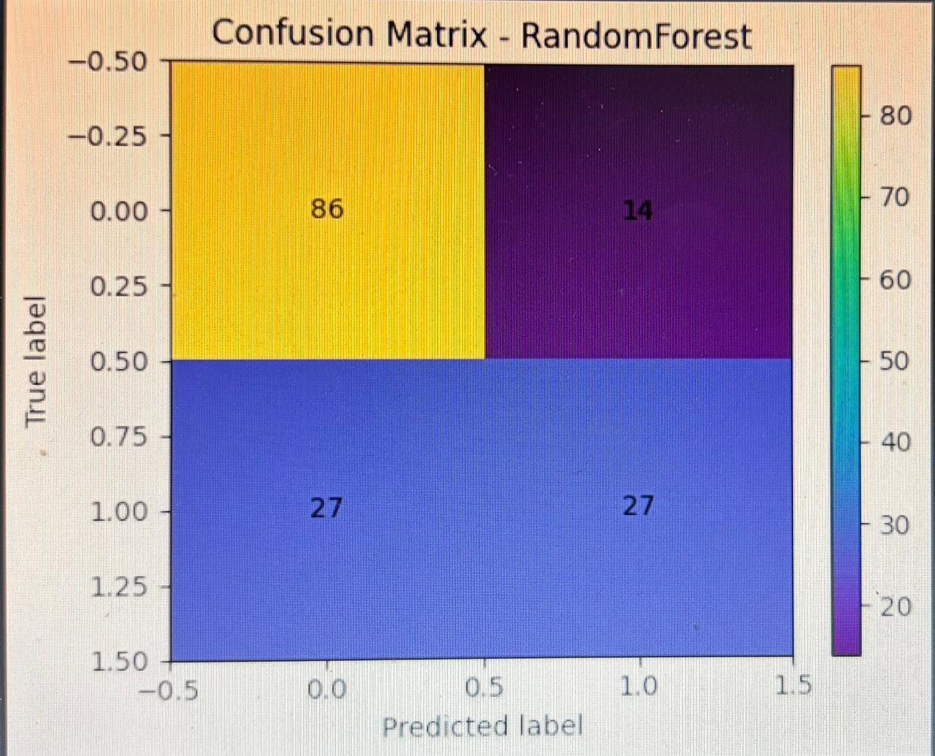
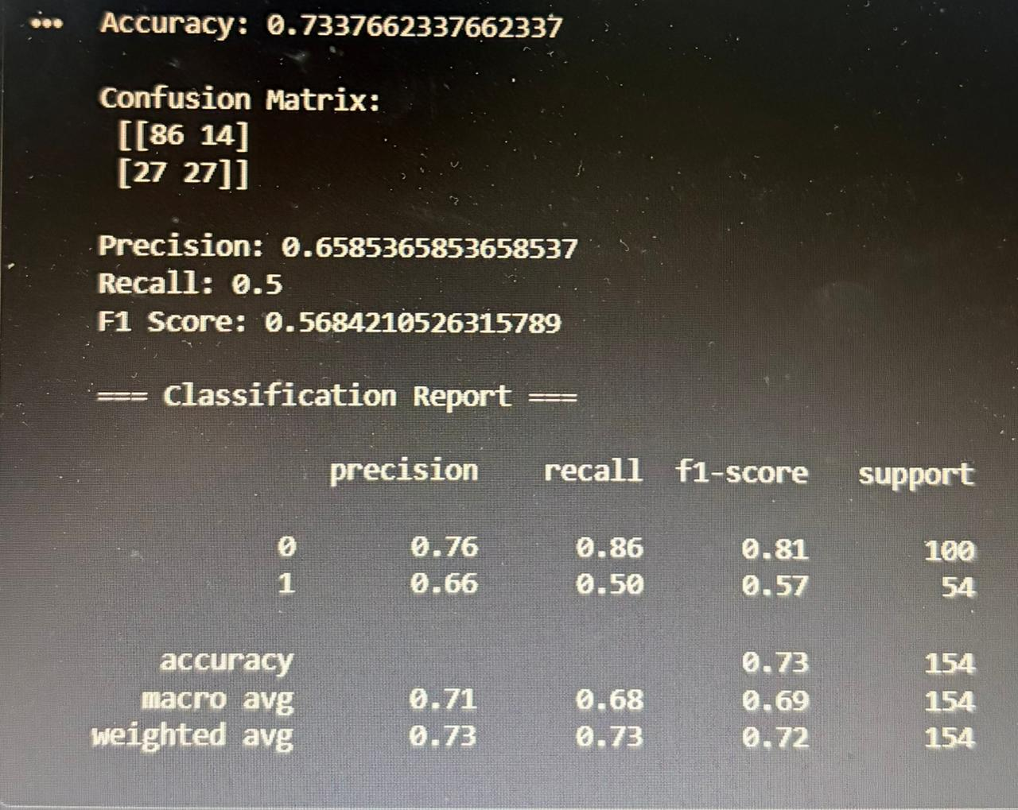
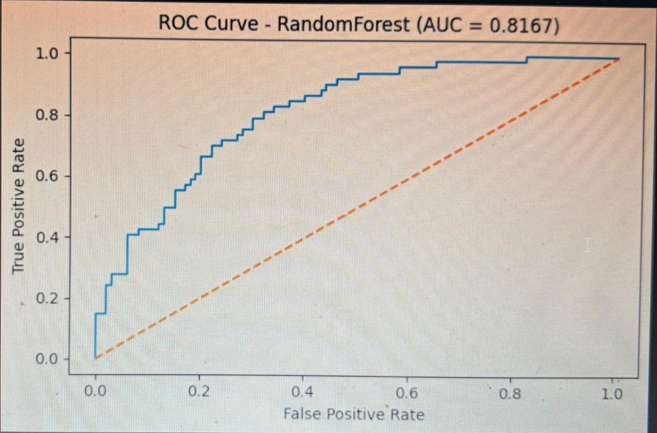

5. Conclusion
This project aimed to predict diabetes using machine learning techniques. The dataset was preprocessed, scaled, and trained on different models to understand their performance. Among all the algorithms used, the Random Forest Classifier gave the best accuracy and produced more reliable results. The evaluation metrics showed that the model was able to correctly classify most diabetic and non-diabetic cases. This demonstrates that machine learning can support early detection of diabetes. Although it cannot replace medical diagnosis, it can help in screening and identifying high-risk individuals. The project also shows that using more features and a larger dataset can further improve accuracy. Overall, the model successfully achieved the objective of predicting diabetes and provides a strong foundation for future improvements.

